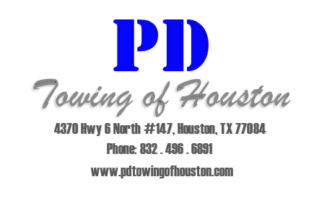
Covered Parking Addendum Notice

ATTENTION ALL RESIDENTS OF: ____________________________________

This notice is to inform and notify you and your guest that we will be enforcing towing unauthorized vehicles in the covered parking spaces as of _____/_____/______.
It is your responsibility to inform your guests where visitor parking is located and that they can only park there. If you fail to provide them with this information or they fail to fail to park in visitor parking, their vehicle WILL BE TOWED at the vehicle owner’s expense.
If you or your guests parks in a covered parking space that you do not pay for that space, the vehicle WILL BE TOWED at the vehicle owner’s expense.
If you have any questions or concerns regarding Towing Enforcement or would like to lease a covered parking space, please contact the leasing office during regular business hours.
Thank you for your patience during these changes.

