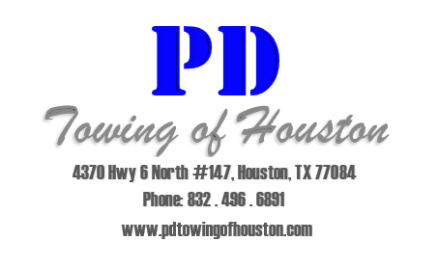
Parking Lot Striping

We offer a high quality Parking Lot Striping service at a discount to all of our clients. We have a professional Parking Lot Painting department dedicated to provide the best product with little to no inconvenience to management, staff, and residents.
We use high quality chlorinated rubber paint and cutting edge equipment allowing most properties to be completed in as little as two days.
Our experienced crew guarantees to be professionally dressed, on time, and will meet all deadlines as requested by management while still providing the best job in the industry.
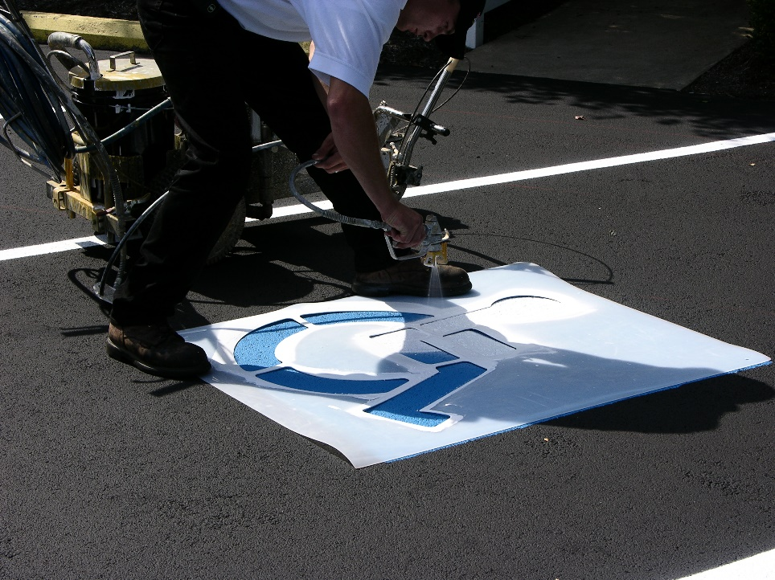
Paint quotes are available through our home office Monday thru Friday and are often able to be completed within one business day. Our longstanding relationships with suppliers allows us the ability to provide the best pricing on materials, which we are able to pass along to our clients often providing materials at cost.

