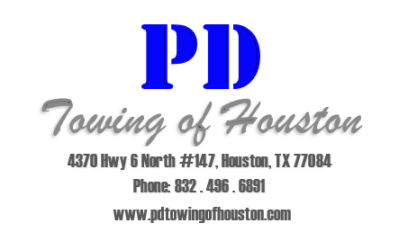
Parking Violations

We can tow vehicles for a number of reasons including lease and/or parking violations in accordance with your preferences.
Some of the violations we can tow for include:
- Blocking of Fire Lanes and Tow Away Zones
- Double Parking behind vehicles and over the line.
- Blocking entrances, exits, and sidewalks.
- Blocking garages, driveways, and dumpsters.
- Parking in on the grass and curbs.
- Violating a “Head In Parking Only” mandate.
- Public Safety Threats i.e. vehicles on jacks, jack stands, or blocks.
- Vehicles leaking fluids.
- Parking Permit violations.
- Reserved and Covered Parking Permit violations.

We have a variety of parking permits and hang tags that can be customized to the needs of your property. We also provide a unique permit known as “VIP” permits, these permits are solely for managers and staff.

